교재: C Primer Plus, Sixth Edition, Stephen Prata

□○•★▶

1. Getting Ready

1.1 Why C?

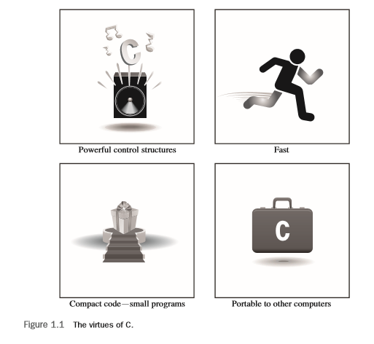

□ Design Features

* natural for top-down planning, structured programming, and modular design

□ Efficiency

* compact and to run quickly

□ Portability

* C programs written on one system can be run on other systems with little or no modification

□ Power and Flexibility

* Unix operating system was written in C
* FORTRAN, Perl, Python, Pascal, LISP, Logo, and BASIC—have been written in C
* C programs have been used for solving physics and engineering problems

□ Programmer Oriented

* It gives you access to hardware, and it enables you to manipulate individual bits in memory

□ Shortcomings

* C’s freedom of expression also requires added responsibility
  + C’s use of pointers can make programming errors that are difficult to trace.
* the price of liberty is eternal vigilance

1.2 Whither C?

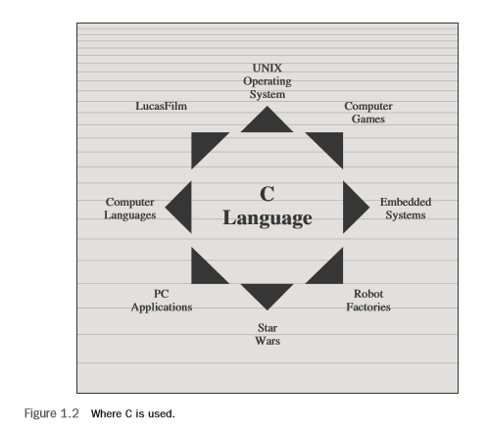

* C is one of the most important programming languages and will continue to be so
* If you want a job writing software, one of the first questions you should be able to answer yes to is “Oh say, can you C?”

1.3 High-level Computer Languages and Compilers

* total = mine + yours;
* the machine-language equivalent of several instructions expressed in numeric code
* The compiler is a program that translates the high-level language program into the detailed set of machine language instructions the computer requires.

1.4 Using C: Seven Steps

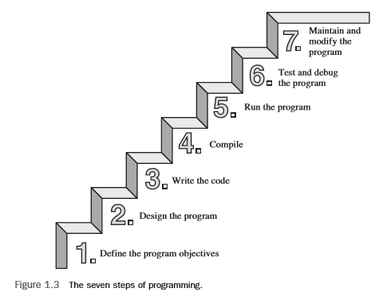

□ Step 1: Define the Program Objectives

* you should start with a clear idea of what you want the program to do

□ Step 2: Design the Program

* you should decide how the program will go about it. What should the user interface be like? How should the program be organized? Who will the target user be? How much time do you have to complete the program?
* You need to decide how to represent the data in the program as well as which methods to use to process the data

□ Step 3: Write the Code

* you translate your program design into the C language
* you use a text editor to create what is called a source code file
  + scanf() 실행 오류 -> 전처리 설정, _CRT_SECURE_NO_WARINGS
  + 12 = dogs; //lvalue 오류
  + getchar(); #include <conio.h>사용하여 화면 정지하는 것을 보여주는 실습

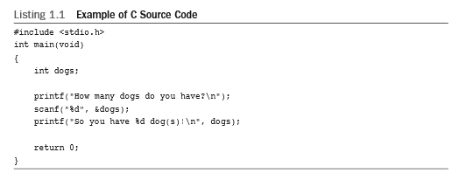

□ Step 4: Compile

* the compiler is a program whose job is to convert source code into executable code
  + Executable code is code in the machine language of your computer
  + a program called a linker brings in the library routines, but the compiler runs the linker for you on most systems. The end result is an executable file containing code that the computer understands and that you can run.

□ Step 5: Run the Program

* the executable file is a program you can run
  + Integrated development environments (IDEs) allows you to edit and execute your C program from within the IDE by selecting choices from a menu or by pressing special keys.

□ Step 6: Test and Debug the Program

* some of your programs have mistakes— bugs
  + Debugging is the process of finding and fixing program errors.

□ Step 7: Maintain and Modify the Program

* You could add a clever new feature

□ source file

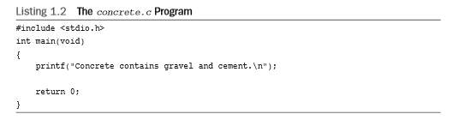

1.5 Object Code Files, Executable Files, and Libraries

□ to use programs that convert your source code file to an executable file

* compiling and linking
* The compiler converts your source code to an intermediate code, and the linker combines this with other code to produce the executable file
* to convert the source code to machine language code, placing the result in an object code file , or object file

□ Nearly all C programs make use of routines (called functions ) that are part of the standard C library

* concrete.c uses the function printf()
* The actual code is stored in another file, called a library . A library file contains object code for many functions.

□ The role of the linker is to bring together these three elements—your object code, and the library code—and put them together into a single file, the executable file.

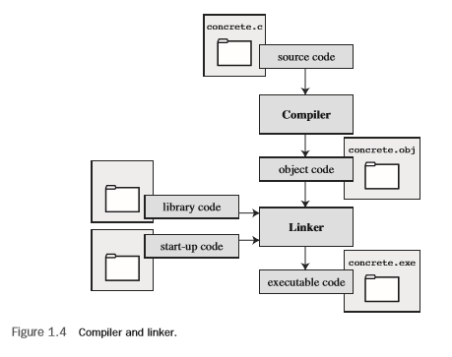

* + 1장은 용어 설명에 대한 퀴즈
  + listing1.1 source code에 대한 퀴즈 시행